
SUMMER JUNIOR PROGRAMME
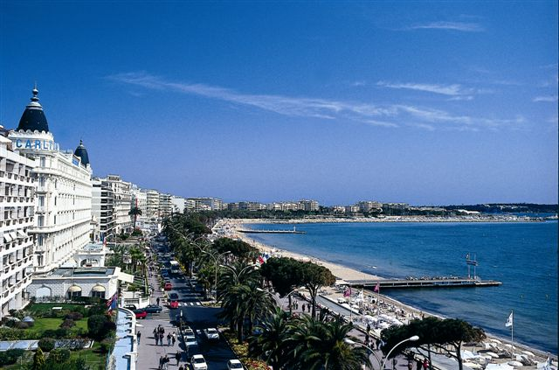

1. TOWN

Cannes is the second largest city of the French Riviera and offers a high-grade year long program of high class entertainment, cultural and exhibitions activities.

2. LOCATION

Arrival on Sunday. Students are picked-up at Nice airport or Cannes railway-station.
The school is located in a very quiet and green area,
at a 10 minutes walk to the Center of Cannes and to the beaches.
Accommodation, classrooms, restaurant and sport facilities.

3. ACCOMMODATION
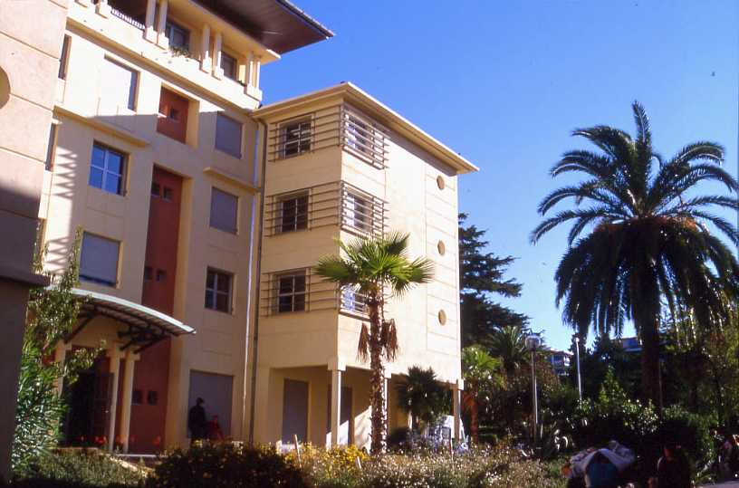

At the school residence with full board.
Modern double room and with private bathroom and toilet.
Or
With a French host family double room with full board.

4. COURSES
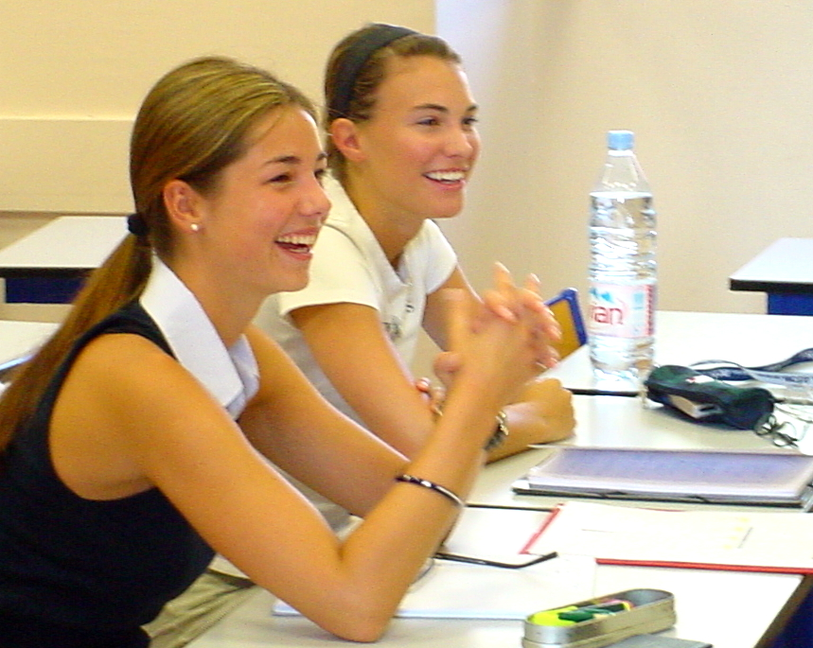

Students will be divided in groups ( maximum of 15 students).
Students will be taking lessons from Monday to Friday
from 9 am to 12.15pm ( 20 lessons/week).

5. WIDE CHOICE OF EXCURSION
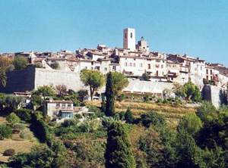
- Antibes and Picasso Museum
- Nice, the old town, Matisse Museum
- St Paul de Vence/ Gorges du Loup/ Gourdon
- Boat cruise to the Lerins Islands, the Monastery
- Visit of a perfume factory
- St Tropez
- Monaco

6- WIDE CHOICE OF ACTIVITIES
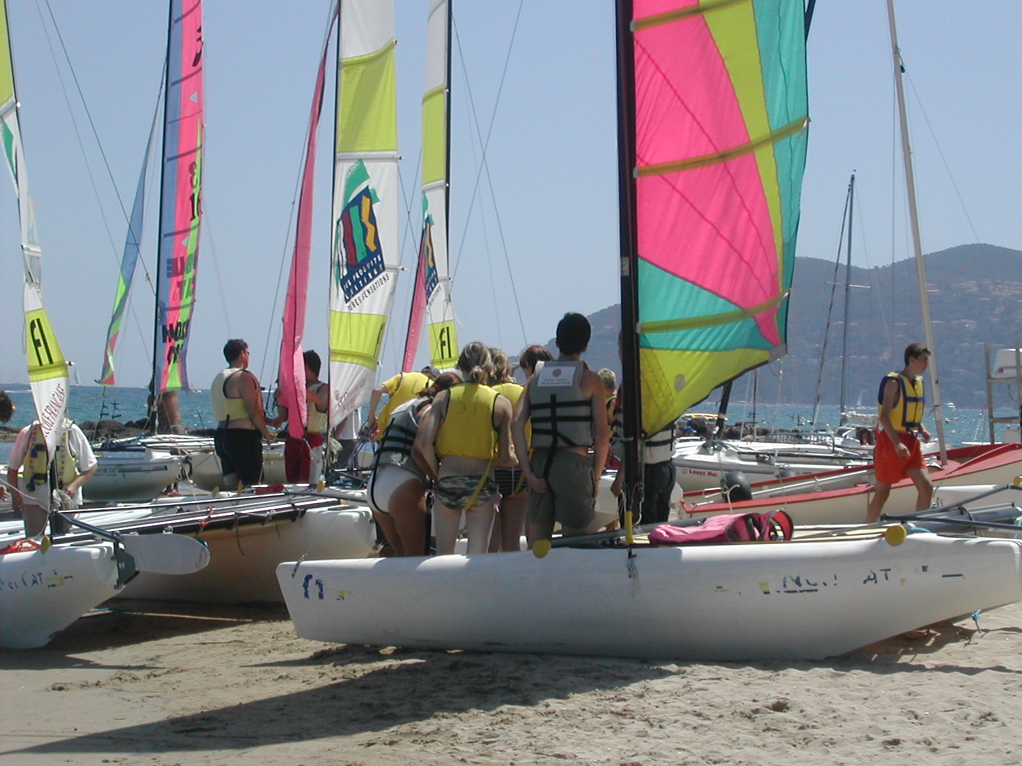

- Boat sailing
- Beach volley
- Evening events
- Manual workshops
- Barbecue evening on the beach
- Fire works
- Tv room

