History of the City
From the 1860's, when financier Darius Ogden Mills purchased land from the Sanchez family to build his country estate, Mills' "brae" or "rolling hills" has enjoyed a colorful history. Mills' estate grew to span Skyline Boulevard to the Bayshore Highway and Millbrae Avenue to Trousdale Drive. Children swam in three lakes situated on the estate and sold acacias to tourists before the Mills family began to sell the land for development. The estate's spectacular mansion burned down in a realistic "fire drill" in 1954, leaving behind a growing community.
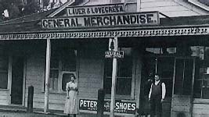
The Lovegreen General Store was located at the corner of El Camino Real and Millbrae Avenue - circa 1906
Policing in Millbrae was conducted by a private patrol which collected fees from merchants and residents until 1941, when the San Mateo County Board of Supervisors created the Millbrae Police District. Records of the Internal Revenue Service document licensing of several Millbrae bars for gambling; only after incorporation were gambling laws enforced in Millbrae and not until the 1950's was gambling defeated. In 1931, citizens organized a volunteer fire department, which remained entirely volunteer until 1938. The police and fire departments were housed together for several years at Hillcrest Boulevard and El Camino Real before the vital services moved to their permanent location in Millbrae's civic center.
Spurred largely by the desire to secure the Mills' estate for residential use and by the efforts of the Millbrae Sun, residents heatedly discussed incorporation for over a decade before voting to incorporate. Finally, on January 14, 1948, residents of Millbrae traveled to Sacramento to present their new City's charter. Mr. W.F. Leutenegger was elected mayor to represent Millbrae's nearly 8,000 residents. That year, Green Hills Elementary School opened as Millbrae's first new school in over twenty-five years, in anticipation of the educational needs of the post-war "baby boom" children. The new City's chief industries were agriculture, floriculture, dairy, and porcelain manufacturing. Many families that built the new City have never left.
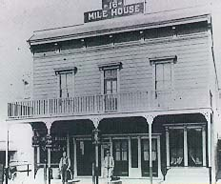
For many Millbrae residents the original 16 Mile House was a direct link to Millbrae's early days. The rest stop was built in 1872 by members of the Sanchez familythe original landholders of the Buri Buri Rancho, which at one time comprised parts of present-day Millbrae and Burlingame
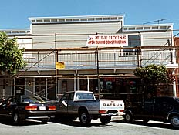
Replica of the original 16 Mile House on Broadway Avenue during recent renovation
In the 1950's, Millbrae residents united to resist efforts to divide the City by freeway. An unsuccessful effort to save the original Sixteen Mile House in the 1970's led to the birth of the Millbrae Historical Society and eventual successful crusades to save the Millbrae train station and the historic building that has become the Millbrae Historical Museum. Such challenges, though inevitable, have only strengthened Millbrae's resolve to preserve the City's unique character and rich history.
Transportation has shaped Millbrae's growth. From the turn of the century, the #40 "interurban" streetcar traveled through Millbrae, linking the City with San Francisco and San Mateo. Millbrae's high school children rode the streetcar to attend Burlingame High School until Capuchino High School opened in 1950. The streetcar line was dismantled just after Millbrae's incorporation, leaving the Southern Pacific Railroad as the only railway linking Millbrae with surrounding areas. The Sixteen Mile House marked Millbrae along the railroad route, located where Millbrae's first Corner Frame Shop stands today. In the 1940's, long-time residents vividly recall, a hilltop literally was shaved away to produce landfill for expanding San Francisco International Airport.
Today, Millbrae boasts over 21,000 residents of diverse ethnic, national, and cultural backgrounds. Residents are employed in various industries throughout the Bay Area and children attend one of five public elementary schools, or private schools. The City's senior citizen community, with the eager generosity of the City's many service clubs and private donations, recently dedicated an attractive new senior wing within the Millbrae community center. Millbrae's approach is demarcated by a picturesque new overpass. A small city with global vision, Millbrae proudly nurtures Sister City relationships with La Serena, Chile, and Mosta, Malta.
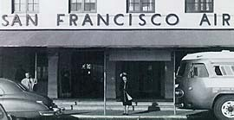
San Francisco Airport - formerly Mills Field, now San Francisco International Airport - during the 1950's
Together Millbrae residents meet the challenges and enjoy the benefits presented by the City's unique position adjacent to an international airport and a mecca city. The airport continues to expand and Millbrae's economy remains inextricably linked to the airport and the tourism it engenders. Millbrae retains its "small town" feel, while undergoing a major downtown revitalization and anticipating the entry of regional transit into the City. Hilltop to bayshore, residents and visitors revel in the City's spirit of community and scenic splendors.

General Information
Facts and Figures
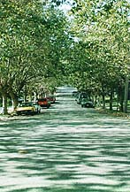  Population: | 20,718 (2000 Census)
Incorporated: | January 14, 1948
San Mateo County Seat Established: | 1856
Land Area: | 3.2 Square Miles
Registered Voters: | 11,432 (1/98)
Number Of Households: | 8,113 - Units (2000 Census)  7,956 - Occupied
Location
Millbrae City Hall  621 Magnolia Ave.  Millbrae, CA 94030 |  | Millbrae Community Center  477 Lincoln Circle  Millbrae, CA 94030
The City of Millbrae is located on the Peninsula, 15 miles south of San Francisco. The boundaries of this city extend roughly from the Bayshore Freeway on the east to Skyline Boulevard on the west. This distance is approximately 1.7 miles. The distance between the north and south city limit line is approximately 2.05 miles.
Government
Millbrae operates as a General Law City, provides for a Council-City Administrator form of government which clearly distinguishes the legislative powers of the City Council from the Administrative powers of the City Administrator.
Elections
General Municipal Elections are held on the first Tuesday after the first Monday in November of odd-numbered years.

